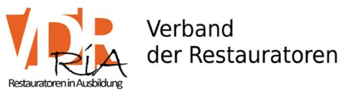
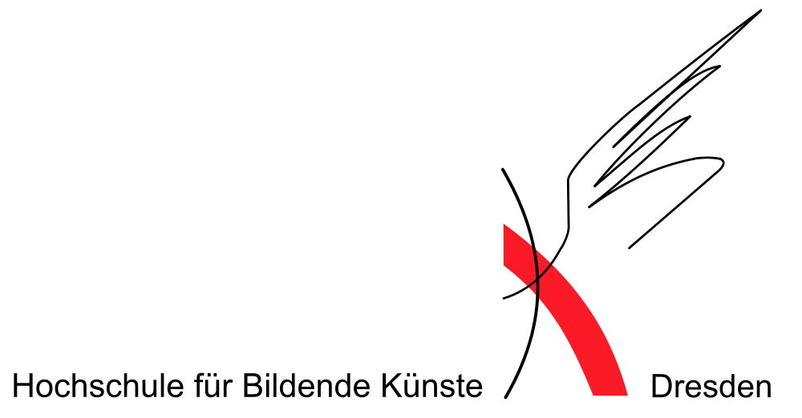
Academy of fine arts Dresden
Organisationteam of the Student Colloquium
VDRstudentenkolloquium@gmx.de

rt, Datum

Verband der Restauratoren (VDR) e.V.
Interessengruppe Restauratoren in Ausbildung
Anneke Horstmann⏐Isabelle Streich ⏐Dennis Mitschke
info-ria@restauratoren.de
m
rt, Datum

Abstract – Form
For the 8th Student Colloquium (StuCo) 2018 in Dresden 23trd - 24th June 2018
Name and surename:
Membership number:
Just for VDR-Members
University / internship:
Course of studies / Specialisatzion:
Semester / year of internship:
Titel of lecture:
Abstract (approx. 200 words):
Presentation conditions:
Approx. 15 minutes + 10 minutes discussion, please use Powerpoint/ PDF-Foiles.
In addition to presentations, exhibitions of posters are also possible.
Please also send a meaningful photo to your abstract.

Release of Data
My data (name, position, city, country, e-mail) may be published in the list of participants.
yes no
My contact details may be published in the program/abstract booklet for the Colloquium.
yes no
You can use the following contact details in the program booklet.
adress
e-mail
phone
other
I hereby confirm that the picture material I have enclosed is released for publication by the VDR in digital and printed form and does not violate any applicable legal provisions, in particular those of data protection and copyright law.

Supporting program
I would like to participate in the barbecue on Saturday, 23.06.2018.
yes no
Preference for the food
omnivore
vegetarian
vegan

Meeting with the interest group RiA
I would like to participate in the meeting with the RiA (date will be announced).

Participation fees are waived. Deadline for the Abstract: 1st May
Please fill in the form and send your documents to: VDRstudentenkolloquium@gmx.de
The exact dates and the program will be announced at a later date.
We look forward to your submissions,

Your Stuco-team

